Emergency Response

The following is a necessary aspect of leading any Harvard Trip. While it looks like a lot it is absolutely critical that you bring a copy of this document. The information is important to not only you, as leaders, but also for anyone back on campus who has to help coordinate an emergency response should the unfortunate happen. Please have completed and reviewed this document before you email the trip guru with your leader paperwork.

The document consists of 7 Parts.

- Emergency

- Emergency Call Guide

- Evacuation Considerations

- Emergency Response Questions

- Useful Emergency Numbers

If a situation arises follow the “Emergency” procedures. Do not text/call until you have gathered all necessary information. Always text before you call. A text requires less service and will often go through when a call will not. The “Emergency Call Guide” is a helpful chart to fill out before you text/call. Evacuation Considerations can help you think through your response to a situation. Emergency Response questions are for the on campus call person. They will elicit the necessary information such that they can help guide the person in the field. Finally, use the On Campus Call Person schedule to meet with that person the week of your trip.

Emergency

If there is a life-threatening Emergency contact 911.

Else:
- Asses Situation
  - Number of missing/ill/injured persons
  - Risks to rescuers
    - Identify Risks
    - Mitigate Risks
    - Do not undertake a rescue you are not adequately prepared for, e.g. cliff rescue, whitewater rescue.
- Treat Patient
  - Complete Primary & Secondary Assessment.
  - Treat patient.
  - Record everything.
- Draw up and complete SOAP note or Emergency Call Guide Chart (below)
  - Subjective: what happened
  - Objective: Patient vitals, patient exam, signs/symptoms
  - Assessment: Diagnosis
  - Plan (See Evacuation Considerations below)
    - Ideal (e.g. helicopter evacuation)
    - Secondary (assisted evacuation, etc)
- Upon Completion of the above you can text the On Campus Call Person
  - (501) 313-1462
  - The on campus call person can help advise you.
  - Use the red/yellow/green-light protocol. (See Emergency Call). Be sure to specify your name and location followed by a brief message and the amount of time you will wait until you call:
  - Bring them up to speed on situation
  - They will ask the questions “Emergency Response Questions” below

Emergency Call Guide

Fill out this table before sending text:

Nature of Call  (Circle one)  Response Time | RED  Life threatening emergency  Immediate | YELLOW  Stable but urgent  Help needed  < 24 hours |  | GREEN  Course quality or non-urgent help needed situation  No help required within 24 hours
Name of Caller:
Time of Call:
Your Phone Number:
LOCATION (specific details of position):
SITUATION
Name of injured person(s):

Injuries:

Actions taken/being taken:

PLAN OF ACTION (What actions need to be taken):
When Will Your Next Communication Be?
Date: |  |  | Time:

Evacuation Considerations
Questions to Consider before proceeding with an evacuation
_____ How much daylight do you have?
_____ What is the weather? Is it changing? For the worse?
_____ Can you continue to provide the necessary first aid treatment and monitoring during the evacuation?
_____ What if your patient’s condition deteriorates? Would it be more difficult to treat him/her once you start hiking our?
_____ How many people do you have to do the evacuation? For a litter evacuation you should plan to have a minimum of 3 teams of 6-8 people rotating through the litter carry.
Evacuation Flow Chart
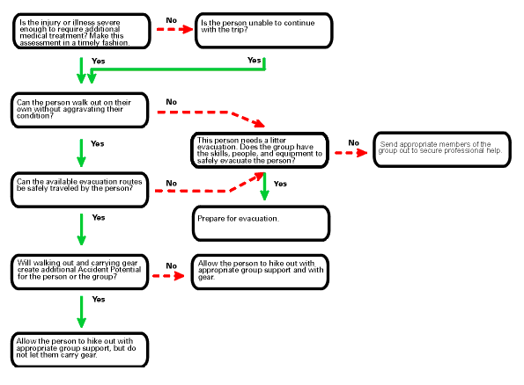

Emergency Response Questions
- Who is calling
- Where are they calling from (exact location)
- What is their phone number
  - Can I call back?
  - If no, determine a plan to contact them again
- Interview Caller to determine problem
  - Basically their SOAP note
    - What happened?
    - What are the patient vitals, signs/symptoms, diagnosis
    - What is the treatment plan?
  - Leaders may underestimate the nature of the problem. A conservative medical response is best.
- Triage: How serious is the situation. Classify with the below.
  - Class I - minor medical problem. Person can remain on the trip.
  - Class II - minor medical problem. Person can be evaluated/treated on campus (at UHS)
  - Class III - moderate medical problem. Person must be treated or evaluated at medical facility.
  - Class IV - serious medical problem.
    - Treatment at trailhead
    - Backcountry treatment necessary
- Talk through to determine proper Evacuation Plan/Response
  - Patient hikes out under their own problem
    - How long will this take?
    - What if it takes longer?
      - Weather conditions/daylight hours.
    - What if patient deteriorates, can their condition be monitored during evacuation?
    - Can they be treated during evacuation?
  - Patient hikes out with assistance
    - How long will this take?
    - What if it takes longer?
      - Weather conditions/daylight hours.
    - What if patient deteriorates, can their condition be monitored during evacuation?
    - Can they be treated during evacuation?
  - Patient needs litter evacuation
    - How long will this take?
    - What if it takes longer?
      - Weather/daylight hours
    - What if the patient’s condition deteriorates
  - Patient needs helicopter airlift
    - How long will this take?
    - What if it takes longer?
    - What if patient’s condition deteriorates?
- Medical Response
  - Patient treated on campus
  - Leaders bring patient to be treated at local hospital
  - Patient treated by EMS at trailhead
  - Patient treated by EMS/rescue team in backcountry
  - Patient treated by Advanced Rescue Team/Helicopter
- Notification
- Follow-up
  - How is the group doing? Do they need to be evacuated for emotional support?
  - Will the group need follow-up support and/or counseling upon return to campus?
  - Will the leaders need follow-up support and/or counseling upon return to campus?

Useful Emergency Numbers
New Hampshire
State Police: 911 or (800) 525-5555
Poison Control: 800-562-8236
Fish & Game: 603-271-3361

Maine
State Police: 911 or 800-452-4664
Poison Control: 800-222-1222
Fish & Game: 207-547-5305

Hospitals

New Hampshire Hospitals
Central Whites: Littleton Hospital 800-464-7731
Pemis South: Speare Memorial Hospital 603-536-1120
Eastern Whites/Carters: North Conway Memorial 603-356-5461
Northern Whites/Mahoosucs: Androscoggin Valley 603-752-2200

Sunapee:
Concord Hospital 603-225-2711
Dartmouth Medical Center 603-650-5000

Maine Hospitals
Rumford: Rumford Hospital 207-369-1000
Farmington: Franklin Memorial Hospital 207-778-6031

IN THE EVENT OF AN EMERGENCY TEXT/CALL THE HOC Emergency NUMBER: (501) 313-1462

